#61DAC Sponsor & Exhibitor Marketing Kit

Use the graphics and text below to promote your exhibit space or participation at the 61st DAC – The Chips to Systems Conference this June in San Francisco, CA.

“I’m Exhibiting”

Twitter
[Company handle/name] will be exhibiting at @61stDAC this summer, June 23-27. Register today and visit us at [booth #] in San Francisco! https://www.dac.com/ #61DAC

LinkedIn and Facebook
[Company handle/name] will be exhibiting at 61st DAC – The Chips to Systems Conference, this summer, June 23-27. Register today and visit us at [booth #] in San Francisco! https://www.dac.com/ #61DAC

“Register for FREE with I LOVE DAC”
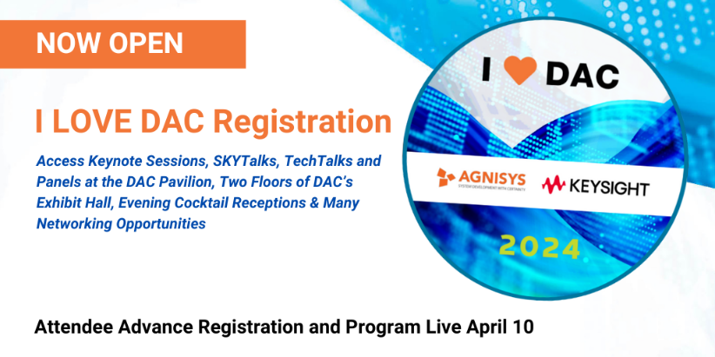
Twitter
@61stDAC is the premier event for the entire ecosystem of electronic design and design automation. From AI to Security, experience DAC for FREE with the I LOVE DAC pass. Register now at: https://www.dac.com/

LinkedIn and Facebook
The 61st DAC – The Chips to Systems Conference is the premier event for the entire ecosystem of electronic design and design automation of electronic circuits and systems. From chips to systems, from AI to Cloud, experience DAC for FREE when you register with the I LOVE DAC pass. Receive complimentary access to the exhibit hall, keynotes, talks and more. Register now at: https://www.dac.com/

“View the Full Program”
Twitter
Join [company handle/name] at @61stDAC, where you’ll discover the latest research and tech driving innovation in #EDA, #AI, #Security, #Cloud, #IP, and #EmbeddedSystems. Don’t miss out! https://61dac.conference-program.com/

LinkedIn and Facebook
Join [company handle/name] at the 61st DAC – The Chips to Systems Conference, where you’ll discover the latest research and tech driving innovation in the ecosystem of electronic design and design automation of electronic circuits and systems. See content focused on #EDA, #AI, #Security, #Cloud, #IP, and #EmbeddedSystems all in one location. View the full program here: https://61dac.conference-program.com/

“Don’t Miss This Session”
Twitter
[Individual name] from [company handle/name] will present their session @61stDAC. Don’t miss [session title] by registering today! https://www.dac.com/

LinkedIn and Facebook
Don’t miss the upcoming session by [individual name] from [company handle/name] as they present their session, [session title] at the 61st DAC – The Chips to Systems Conference. Register for a Full Conference pass to see this session and all sessions offered at #61DAC at https://www.dac.com/

